Unit 5 Day 11

Which weather do you like best?

Sunny Snowy

Rainy Windy

What is the beginning sound in these words?

Cat Can /k/

What is the beginning sound in these words?

Let Leg /l/

Say these words out loud. Which words have the same beginning sounds?

dog run duck rain

Dog and duck have the same beginning sounds.

Can you say the beginning sound? /d/

Run and rain have the same beginning sounds.

Can you say the beginning sound? /r/

We have 5 senses. Do you know any senses?

Hear Taste Touch

Smell See

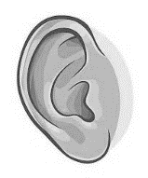

We can hear with our ears.



We can smell with our nose.



We have taste with our mouth.



We see with our eyes.

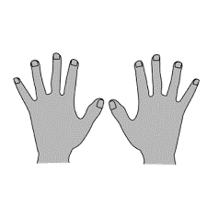

We touch with our hands.

Activities! You are welcome to do all of these activities but please do at least three of them.

1. Have your child write the letters D and R 10 times each.
2. Have your child name 4 things they can see, hear, taste, touch, or smell. Have them write the things down on a separate sheet of paper.
3. Have your child write windy, sunny, snowy, and rainy 5 times each.
4. Have your child point out the different body parts they use for the 5 senses.
5. Have your child practice these simple sight words 5 times each (know, put, stop, let, walk). This means to say the word, have the child say the word, and write the word.